`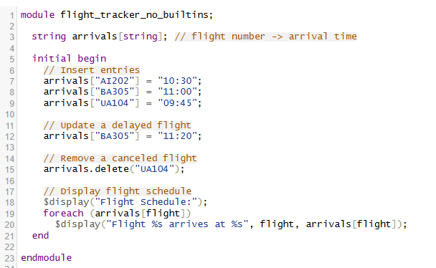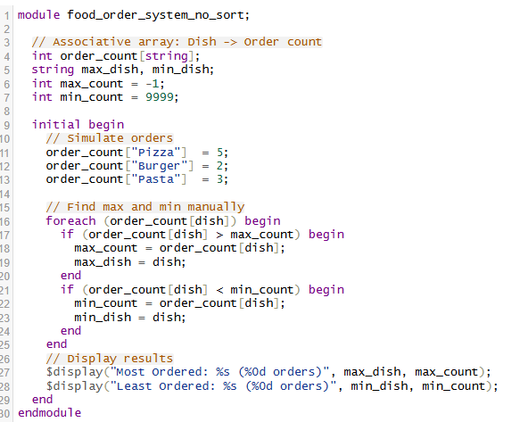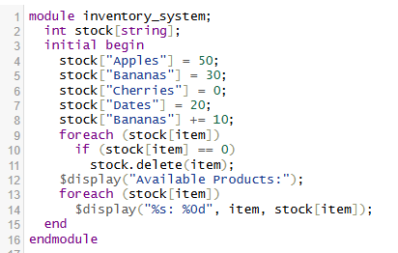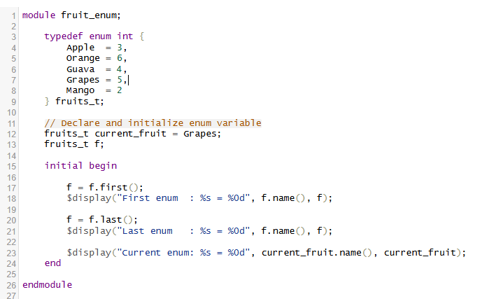
Code: Packed Struct with Fixed-Size Array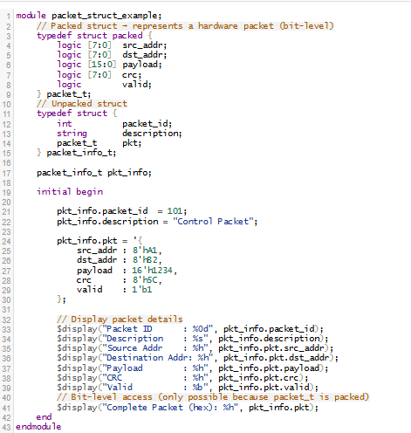

Code: Unpacked Struct with Arrays (Testbench-Style) 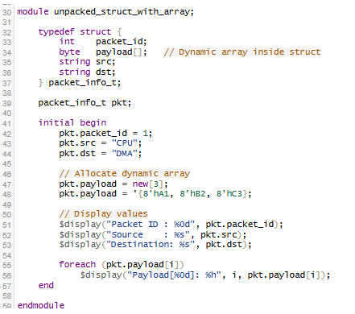
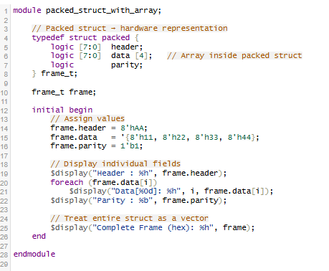
Feature | Packed Struct | Unpacked Struct
Bit-level access | ✅ Yes | ❌ No
Acts like vector | ✅ Yes | ❌ No
Used in DUT | ✅ Yes | ❌ No
Used in TB | ⚠️ Limited | ✅ Yes
Contains string/int | ❌ No | ✅ Yes
